**Continuous control DRL test log**

Test #1 (07012019)

Test info:

250 episodes with 1000 steps per episode using DDPG for 1 agent

Parameter:

BUFFER_SIZE = int(1e5) # replay buffer size

BATCH_SIZE = 128 # minibatch size

GAMMA = 0.99 # discount factor

TAU = 1e-3 # for soft update of target parameters

LR_ACTOR = 1e-4 # learning rate of the actor

LR_CRITIC = 1e-3 # learning rate of the critic

WEIGHT_DECAY = 0 # L2 weight decay

Result

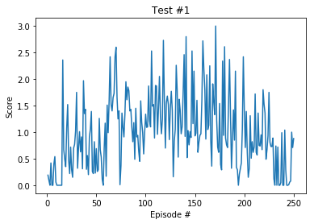

Test #2 (07022019)

Test info:

100 episodes with 1000 steps per episode using DDPG for 1 agent

Parameter:

BUFFER_SIZE = int(1e6) # replay buffer size

BATCH_SIZE = 1000 # minibatch size

GAMMA = 0.99 # discount factor

TAU = 1e-3 # for soft update of target parameters

LR_ACTOR = 1e-4 # learning rate of the actor

LR_CRITIC = 1e-3 # learning rate of the critic

WEIGHT_DECAY = 0 # L2 weight decay

Result

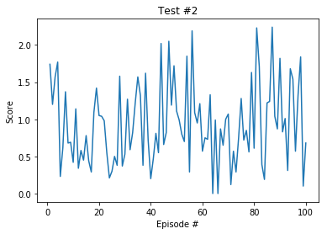

Test #1 (07032019)

Test info:

300 episodes with 1000 steps per episode using DDPG for 1 agent

Parameter:

BUFFER_SIZE = int(1e5) # replay buffer size

BATCH_SIZE = 20 # minibatch size

GAMMA = 0.99 # discount factor

TAU = 1e-3 # for soft update of target parameters

LR_ACTOR = 1e-4 # learning rate of the actor

LR_CRITIC = 1e-3 # learning rate of the critic

WEIGHT_DECAY = 0 # L2 weight decay

Result

